|  |  |
| --- | --- |
| \\VFILERDPI\DPI-Home\OBRIENR2\My Documents\Downloads\PP logo.jpg |  |
| **COUNCIL ASSESSMENT REPORT**  **SUPPLEMENTARY REPORT**  NORTHERN REGIONAL PLANNING PANEL | |

|  |  |
| --- | --- |
| PANEL REFERENCE & DA NUMBER | PPSNH-287- Gwydir DA 48/2023 |
| PROPOSAL | **To construct a new Community Facility and Office Premises complex on the land, including part-retention of the former memorial hall facade. Demolition of the existing facilities is covered under** **PAN-409455** |
| ADDRESS | 33 to 35 Maitland Street Bingara being Lot 20, Section 38, DP758111, Lot 1 DP87721 and Lot B DP 156384.  Access is through 39 and 37 Maitland Street Bingara being Lot 1 DP209422 and Lot A DP 152922 (BK 1566 No 614 and BK 1701 No 95 Right of Way and BK 1566 No 614 Right of Way) |
| APPLICANT | Gwydir Shire Council |
| OWNER | Gwydir Shire Council for Lot 20 Sect 38 DP 758111, Lot 1 DP87721 and Lot B DP 156384.  The registered Right of Way is across two lots – one owned by Nancy Helen Macinnes (Lot 1 in DP 209422) and the other owned by Sylvia May Williams and Amy Louise Iris Evans (Lot A in DP 152922). |
| DA LODGEMENT DATE | 22 February 2024 |
| APPLICATION TYPE (DA, Concept DA, CROWN DA, INTEGRATED, DESIGNATED) | DA |
| REGIONALLY SIGNIFICANT CRITERIA | Clause 3A and 3B, Schedule 6 of *State Environmental Planning Policy (Planning Systems) 2021* :  Council is the applicant and owns the land, and the capital value is above $5,000,000. |
| CIV | $5,050,000 (excluding GST) |
| CLAUSE 4.6 REQUESTS | Nil |
| KEY SEPP/LEP | SEPP (Resilience and Hazards) 2021 – Chapter 4 Remediation of Land  State Environmental Planning Policy (Sustainable Buildings) 2022  Gwydir Local Environmental Management Plan 2013 |
| TOTAL & UNIQUE SUBMISSIONS & KEY ISSUES IN SUBMISSIONS | A single submission was received from the owner of 39 Maitland Street (Lot 1 in DP 209422). This concerned the proposed use of the laneway to the rear of her lot which she indicated she understood that she owns, and has future plans to use. |
| DOCUMENTS SUBMITTED FOR CONSIDERATION | Attachment A – Draft Conditions of Consent  Attachment B – Amended SEE – 27 Nov 2023.  Attachment C – Response to RFI – 5 Feb 2024.  Attachment D – Plan Set for DA Approval. Contains the complete architectural plan set and landscaping plans. |
| SPECIAL INFRASTRUCTURE CONTRIBUTIONS (S7.24) | Nil |
| RECOMMENDATION | Approval with Conditions |
| DRAFT CONDITIONS TO APPLICANT | Yes |
| SCHEDULED MEETING DATE | 21 May 2024 |
| PLAN VERSION | 31 January 2024 Issue B |
| PREPARED BY | Angus Witherby |
| DATE OF REPORT | 7 May 2024 |

**SUPPLEMENTARY REPORT**

This supplementary report addresses questions posed by Panel members in their initial review of the application. The questions, with responses, are detailed below:

1. **Jurisdictional issue re-embodied emissions of the proposal – how has 3.2(2) of the SEPP (Sustainable Buildings) been addressed?**

The consent authority is the Regional Planning Panel. On this basis it is the Panel that needs to be satisfied that the requirements of the SEPP have been met. At the time of original report submission, there was no separate report addressing the embodied energy issues as well as the other energy issues that are required to be addressed. This had been recommended for conditioning prior to issue of the Construction Certificate.

A report is now available, which is provided at **Attachment 1** to this report. Subject to Panel’s acceptance of the report, Condition 10 would be redundant.

**Recommendation:** That, based on the report, the Panel find itself satisfied that the requirements of the SEPP have been met.

1. **Right of Way – further detail to be provided in regard to the details of the agreement noted in Condition 23(b) or alternative proposal if there is no agreement (or any potential legal proceedings)**

Further consideration has been given to the right of way issue. Considerable care needs to be taken with rights of way that are shown on plans prior to the Conveyancing Act of 1919. Essentially, they are of no legal effect unless the appropriate dealings have been lodged to implement the right of way.

In the case of the current right of way, the Certificates of Title of both the lots burdened reference the existence and width of the right of way. These certificates are at **Attachment 2**. Further, the relevant title plans for the two burdened lots have been reviewed. Extracts are also at **Attachment 2**. Each shows the right of way. Due to the notation on title regarding the dealing numbers, there can be confidence that the right of way was actually created, although, to this point, never constructed.

In terms of the current application, consideration has been given to the situation where resolution of the access issue may be delayed. In this regard there are several options moving forward:

* Negotiation with the landholders is successful and an appropriate 88B instrument is implemented subject to any necessary commercial adjustments.
* In the absence of any 88B Council is of the view that the right of way can still be used.
* It is noted that at least one owner may have a different view, and this may need to be tested. In this regard, Council, as a model applicant, should look to either acquire the land, or complete the development without use of the right of way.

**Recommendation:** That the Panel give consideration to an additional condition, which would replace Condition 10 (which is not needed as per recommendation above) as well as an amended Condition 23.

**New Condition 10 – Resolution of Right of Way**

Prior to the issue of a Construction Certificate, and subject to the agreement of the affected landowners, An 88B instrument shall be established over the right of way providing access to the property, which runs across the rear of Lots A DP152922 and Lot 1 DP 209422 (being 37 and 39 Maitland Street) to ensure that:

1. the development site is specifically benefited by the right of way
2. each lot containing the right of way has legal access to the right of way; and
3. to ensure that the maintenance of the right of way rests with the owner of the consolidated development lot as required in Condition 10.

In the absence of landholder agreement, Council shall either:

1. Proceed to acquire the right of way under the provisions of the *Land Acquisition (Just Terms Compensation) Act* or
2. Reconfigure the development to avoid the need to use the right of way. In this regard:
   * 1. A turning area, to cater for a minimum medium rigid vehicle, is to be provided opposite the proposed generator;
     2. The disabled parking space is to be provided between the truck turning area and the main building;
     3. The six other spaces are to be placed at right angles to the access aisle east of the truck turning bay;
     4. The entrance to the main parking area from Cunningham Street shall be labelled and pavement marked for entry and exit.
     5. All the above are to comply with AS2890 Parts 1 and 2 and be to the satisfaction of Council.

Reason: To confirm access to the site, and to adjoining properties

**Amended Condition 23. Consolidation of Lots**

Before the issue of an occupation certificate, the lots, the subject of the development, (with the exception of the right of way) are to be consolidated into a single allotment. This includes the following lots:

* Lots 20 and 38 DP 758111
* Lot 1 DP 87721
* Lot B DP 156384

Reason: To ensure that the development can function without the requirement for rights of way across the existing lots.

1. **Car parking - not covered in conditions at all (including parking for people with a disability) and not adequately covered in assessment report. The report also mentions an increased in staff - does the parking accommodate that?**

Further consideration has been given to the quantum of parking. It is noted that the overall area of built form is reducing from 1461m2 to 1098m2. This is a reduction in area of some 25%. In addition, the former community hall has been demolished, and there is no longer the need to provide for larger events. Depot parking would be accommodated within the main depot site.

The previous site had parking at the rear for four cars only, The proposed office parking area was then informal, and was typically utilised by some 16 vehicles per day. The new development increases spaces at the rear of the building from four to seven, including one space for people with disabilities, while the formalisation of the depot parking provides 22 spaces. Together this makes 29 spaces.

In the absence of a DCP, guidance can come from typical parking rates for different types of development.

* Office space – Typically 1 space per 40m2

Looking to these guidelines, we find:

* 766m2 office space equates to 19 spaces

The community spaces would operate as follows. Council meetings are outside business hours, and ample parking is available on-street with angle parking provided. Toilet usage and counter attendance would generally be by persons already visiting the town centre. Field observation shows that there is no shortage of on-street parking in the vicinity. The tourist information centre would attract visitors to the town, however they, also, would predominantly utilise on-street parking. Accordingly, the ten spaces available in the reconfigured parking are considered adequate to support the community uses.

The plans provide for 29 spaces and are annotated regarding compliance with AS2890. For this reason, a specific condition was not included.

**Recommendation:** That the Panel receive and note the additional material on parking.

1. **Assessment Report page 18 - it would be helpful to have the assessment better address the “Actions to care for Maitland Street” in the Bingara town plan. Some kind of design statement that responds to the 6 points and consideration of an assessment of the proposed architectural style**

The Bingara Town Strategy Plan identifies the Depot site as a key site. The redevelopment of the Council chambers part of the site would not preclude future redevelopment of the depot site for housing, as per the plan, and recommendations in the Housing Strategy that is currently on exhibition.

In addition, consideration has been given to Actions to Care for Maitland Street. The key actions are listed below, together with comments:

1. *Retain deep awnings and awning posts and continue these with any new commercial or mixed use buildings.*

The Memorial Hall did not have awnings, and the commercial building adjacent had a suspended awning. The replacement building is not a commercial building, but a community building. It is important, therefore, that the overall site “reads” in a way that reflects the former Council buildings on the site.

1. *Retain all buildings on the front boundary, and off-street carparking behind buildings.*

Off street carparking is being increased, behind the building. The replacement for the commercial building adjoining the former Council building also has zero setback. For historical reasons, creating a zero setback for the whole site was not supported. The key community issue was retention of the façade of the old memorial hall, which is set back.

1. *Provide detail to new buildings and front facades, incorporating recesses, window detail and brickwork consistent with the Main Street’s character.*

The new building cluster preserves the existing façade of the memorial hall, though specifically conditioning painting treatment to echo an historical palette would be of advantage. The newer section avoids “pretend heritage” but is unashamedly modern. It does, however, have good attention to detailing on the recessed sections. The length addressing the street frontage makes a bold statement, but one which is consistent with monumental architecture associated with memorials. Overall the height and the complexity are consistent with streetscape character, while the setbacks maintain links to the past buildings on the site.

1. *Develop a signage trail – The stories of Bingara, focusing on interesting tales regarding particular buildings, and celebrating history.*

It is proposed, as part of the demolition requirements of the previous buildings, that an interpretive feature be included in the public courtyard. This would be consistent with this action.

1. *Improve the laneways to provide better footpaths, lighting and linkages.*

No laneways are affected by the proposal.

1. *Promote public spaces by encouraging more sitting, gathering and* (sic)

The site provides enhanced public opportunities by creating an attractive public space on the north of the new building. Details of street furniture to encourage seating and mingling would be included in the detailed landscaping plan. A suitable condition is proposed below.

**Recommendation:** That the following additional condition be included that addresses the landscaping of the public area, and also the colour treatment of the former memorial hall façade.

**Condition 10(a) Landscaping and Paint Treatment**

Prior to the issue of a Construction Certificate, the following are to be provided, to Council’s satisfaction:

1. A detailed landscaping plan that includes street furniture within the proposed community open space area to provide seating, tables and the like, to encourage people to gather and utilise the space; and
2. A schedule of paint colours for the former Memorial Hall façade that draw on the historic period of the façade’s original construction.

Reasons: To enhance the appearance of and functionality of the development.

1. **Assessment Report p. 20 – further detail required in regard to designing for safety.**

The issue of CPTED was given careful consideration in the design development. Essentially the tension was between demolishing much of the existing façade to improve surveillance into the site, or retaining an element of considerable importance to the Bingara community. The on-balance decision was taken to keep the main façade elements, but to ensure as much transparency as possible.

Bingara is perceived by its residents as a safe town, as outlined in the Bingara Plan. This is borne out by statistics from the Bureau of Crime Statistics and Research which show that Gwydir Shire is generally low in crime except for domestic violence and stealing/robbery from dwellings and motor vehicles where it is low-mid range.

As part of security approached, the pathway from the community open space towards the rear of the site would be locked at night.

**Recommendation:** That the additional commentary on CPTED be received and noted.

1. **Does the proposal preclude future residential use on the site - refer again the Bingara Town Plan?**

As discussed above, should the depot be relocated in the future, the opportunity exists to implement housing on the former depot component of the site. This is recommended in the Draft Housing Strategy which is currently on exhibition.

A town centre location was considered essential for the Council facility, which brings significant foot traffic to this part of Maitland Street.

**Recommendation:** That the additional commentary on future residential use be received and noted.

1. **Acoustics/noise has limited details in the assessment report – the condition relates to noise output but without going to the source docs (noting that it was a desktop exercise) – further details required to ensure that the Panel can be satisfied that the issue can be managed.**

Noise was given consideration in the RFI document provided following the initial review of the application. Extracts are included at **Attachment 3**.

**Recommendation:** That the supplementary noise information be received and noted.

1. **Contamination assessment and associated condition – the reference in the AR is vague/lacking detail – further details are requested to ensure that the site is suitable for the intended use, with the condition to provide more detail regarding the nature of the required clearance certificate**

Further consideration has been given to contamination. This issue is addressed under the demolition DA. In short, the site has a number of types of contamination as might be expected from buildings of that age. As part of that DA, a report was commissioned from SMK Consultants in Moree, who reviewed the site undertaking a preliminary site investigation. This involved the following steps:

The report identified the following contaminants:

A sampling program was undertaken which focused on the areas with the highest likelihood of contamination. The following results were obtained.

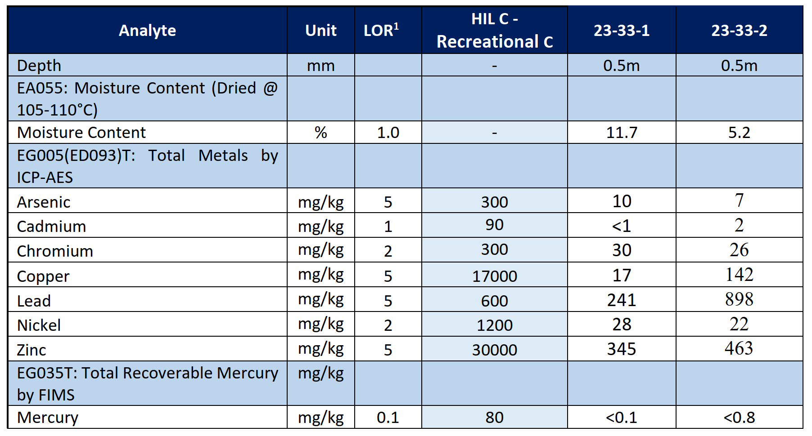

That report identified a staged remediation process.

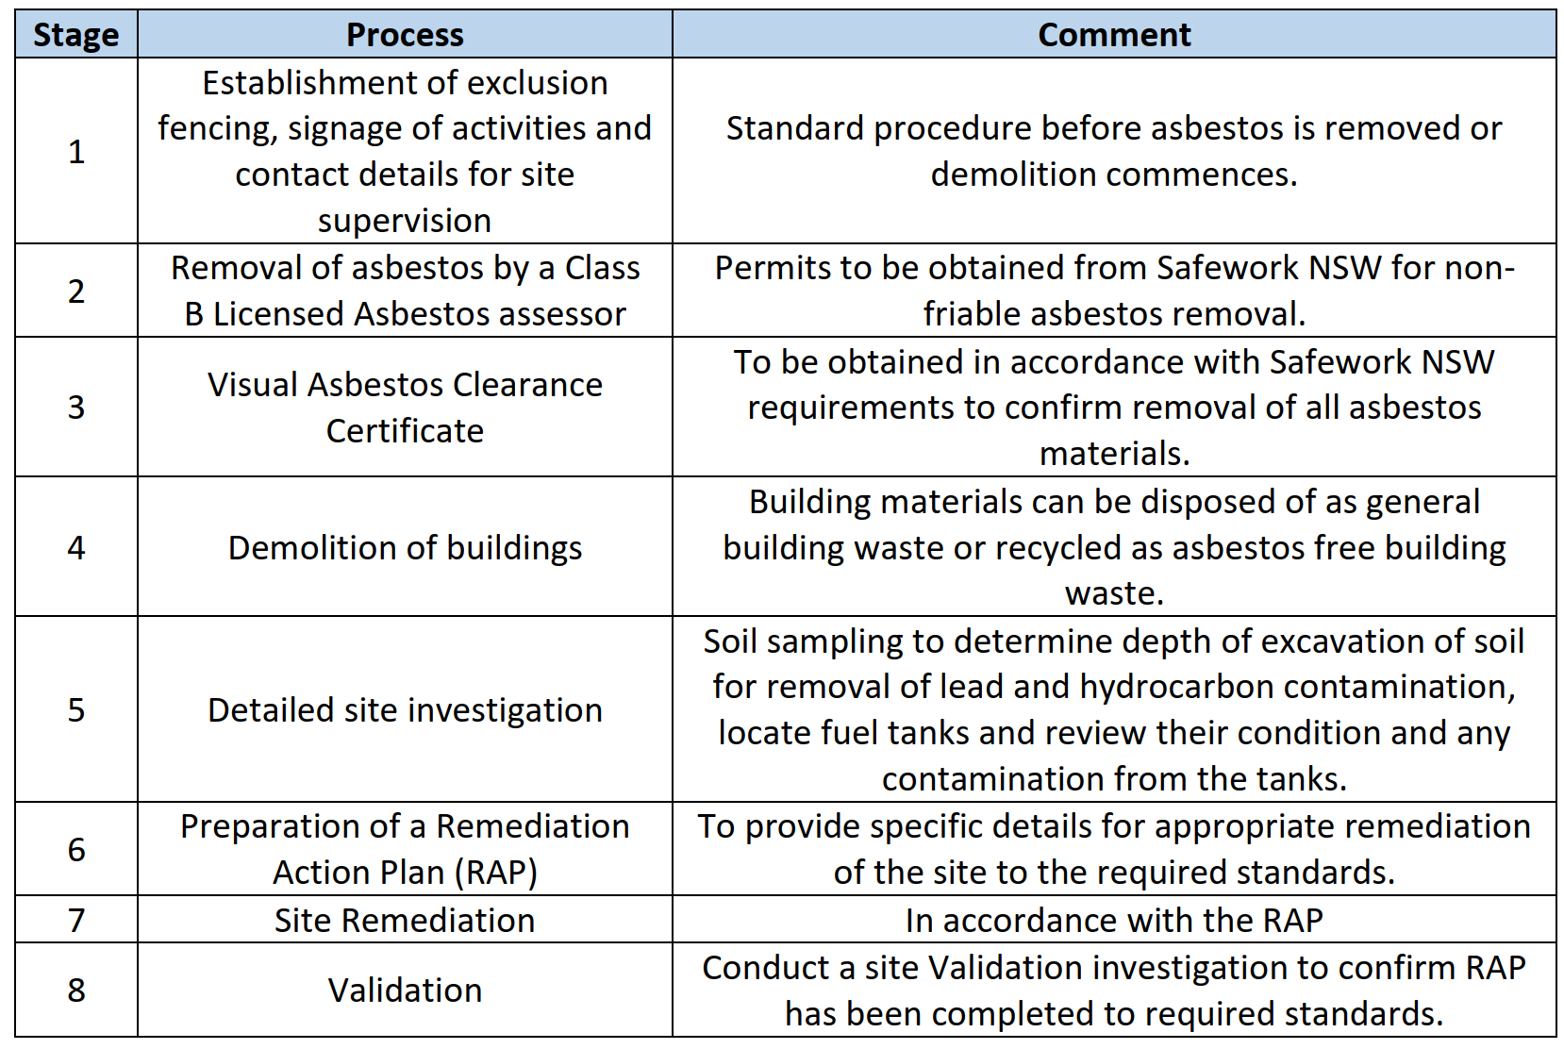

As can be seen from the table, ongoing investigations were recommended during the process as the demolition itself was likely to expose further contamination. This has, in fact, been the case and works are continuing to remediate the site in accordance with EPA protocols. Once the site has been adequately remediated for the proposed use, a site clearance certificate would issue confirming that the site is clear for development.

**Recommendation:** That the Panel receive and note the information.

**ATTACHMENT 1 – Energy Report**

**Attachment 2 – Details on Right of Way**

Lot A

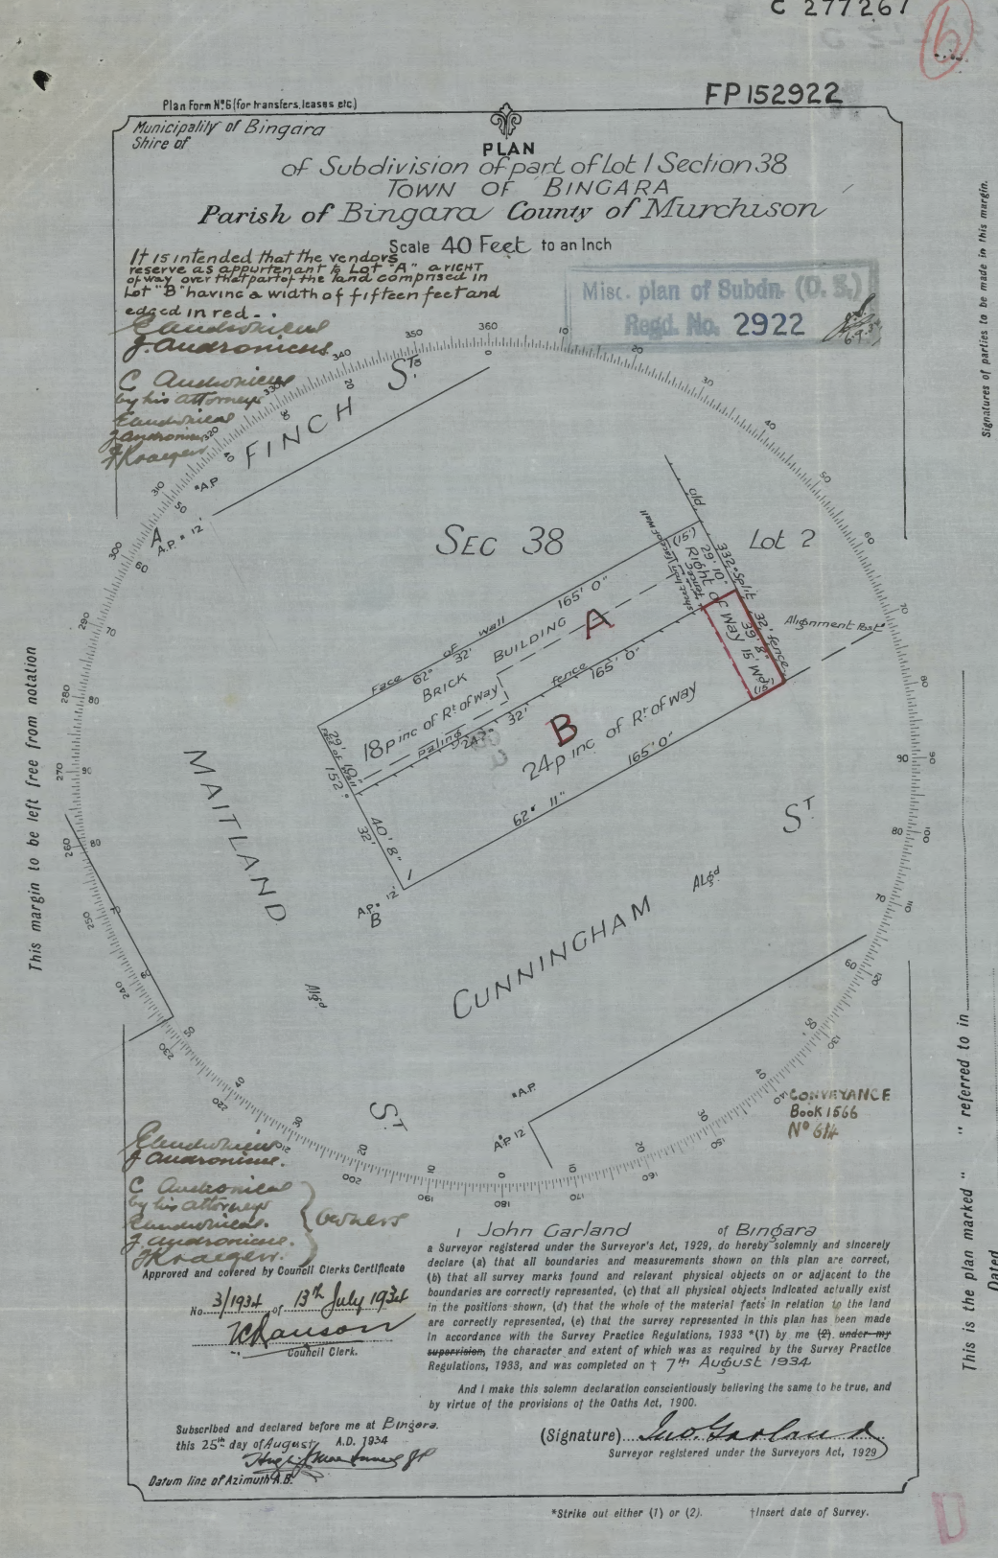

Lot 1

Title Diagram

**Attachment 3 – Extracts – Acoustic Report**

